B2S RESTAURANT

BY B.MANOJH (23CSR125)

AIM:

Creating a responsive website using html (Hyper Text Markup Language) and CSS(Cascading Style Sheets)

SCREENSHOTS:

HOME PAGE:

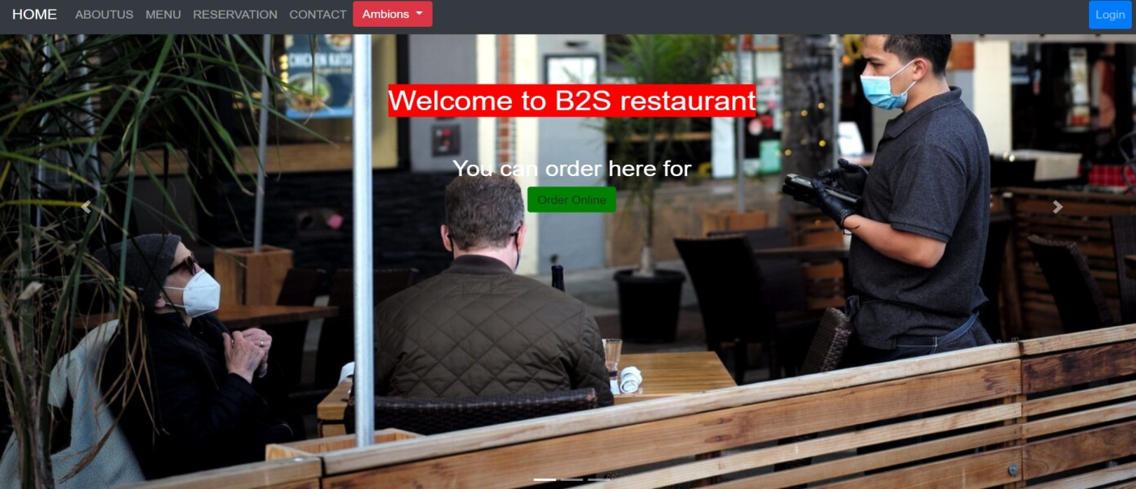

OUR POPULAR DISHES:

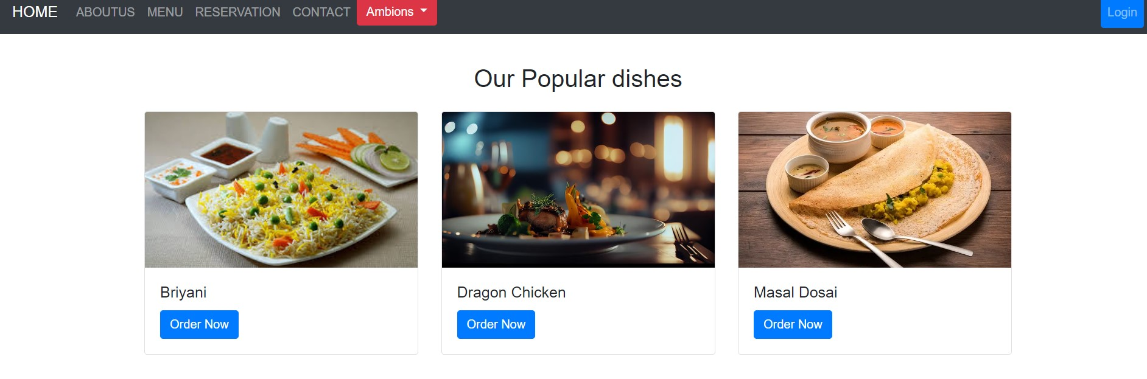

LOGIN PAGE:

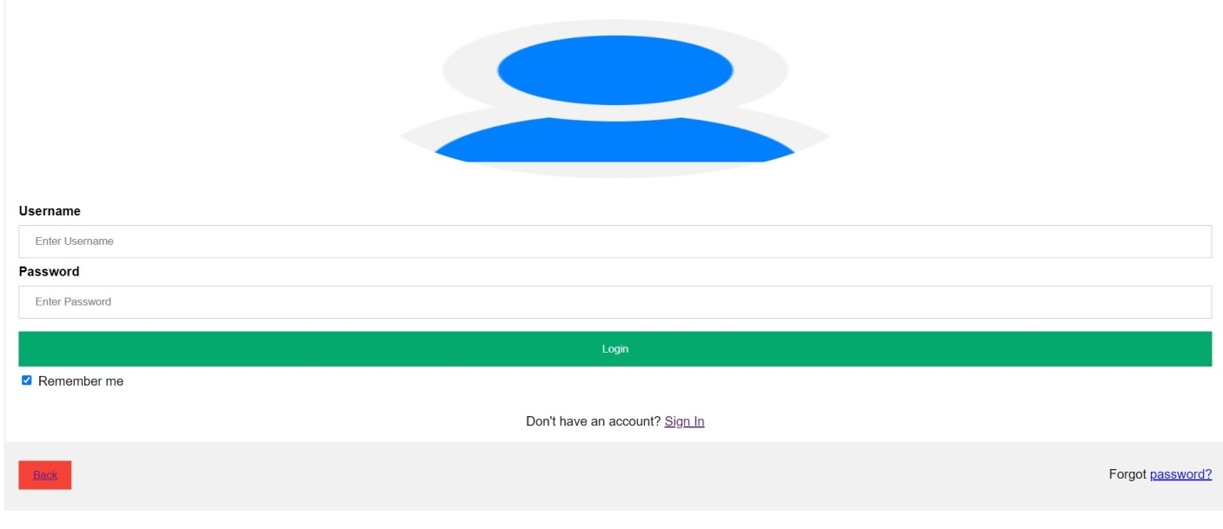

SIGN IN PAGE:

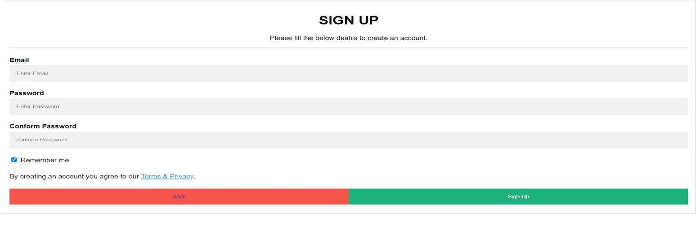

ONLINE ORDER PAGE:

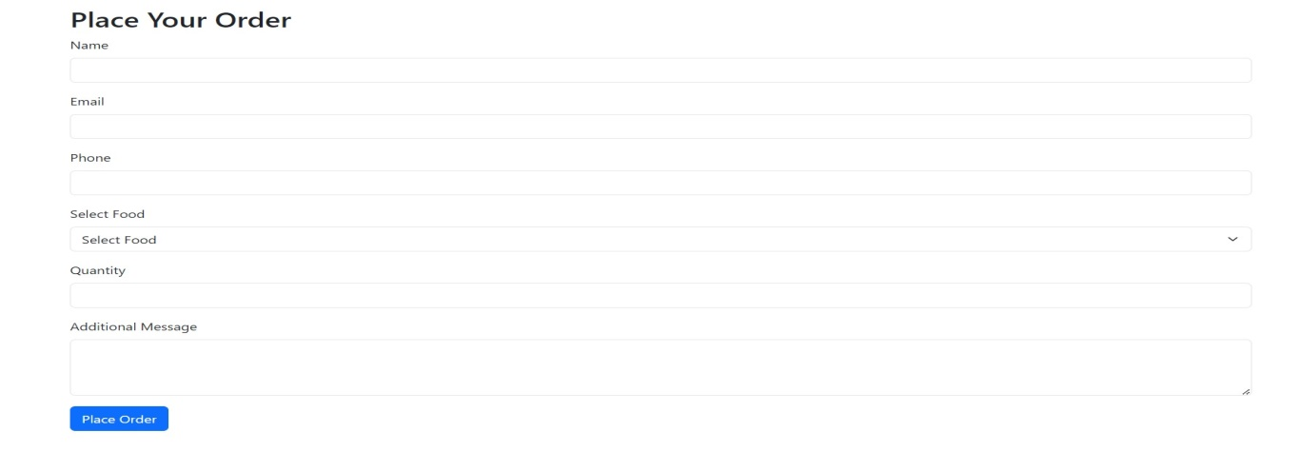

ABOUT US:

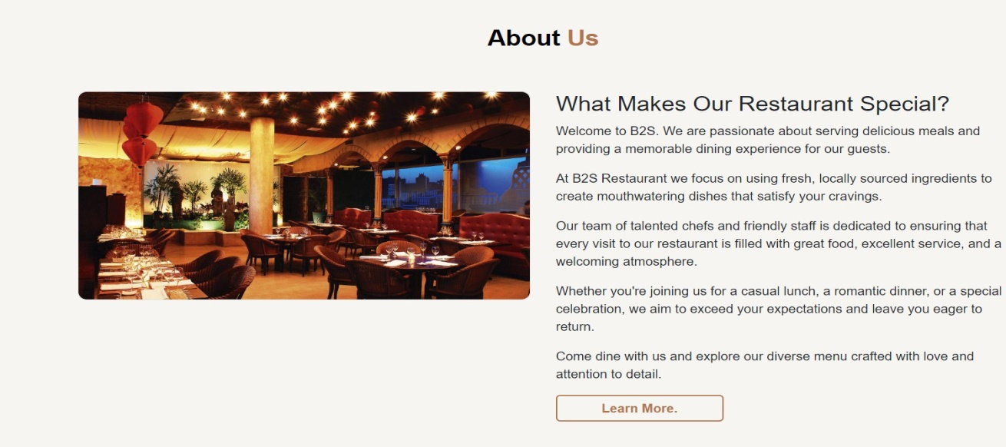

MENU PAGE:

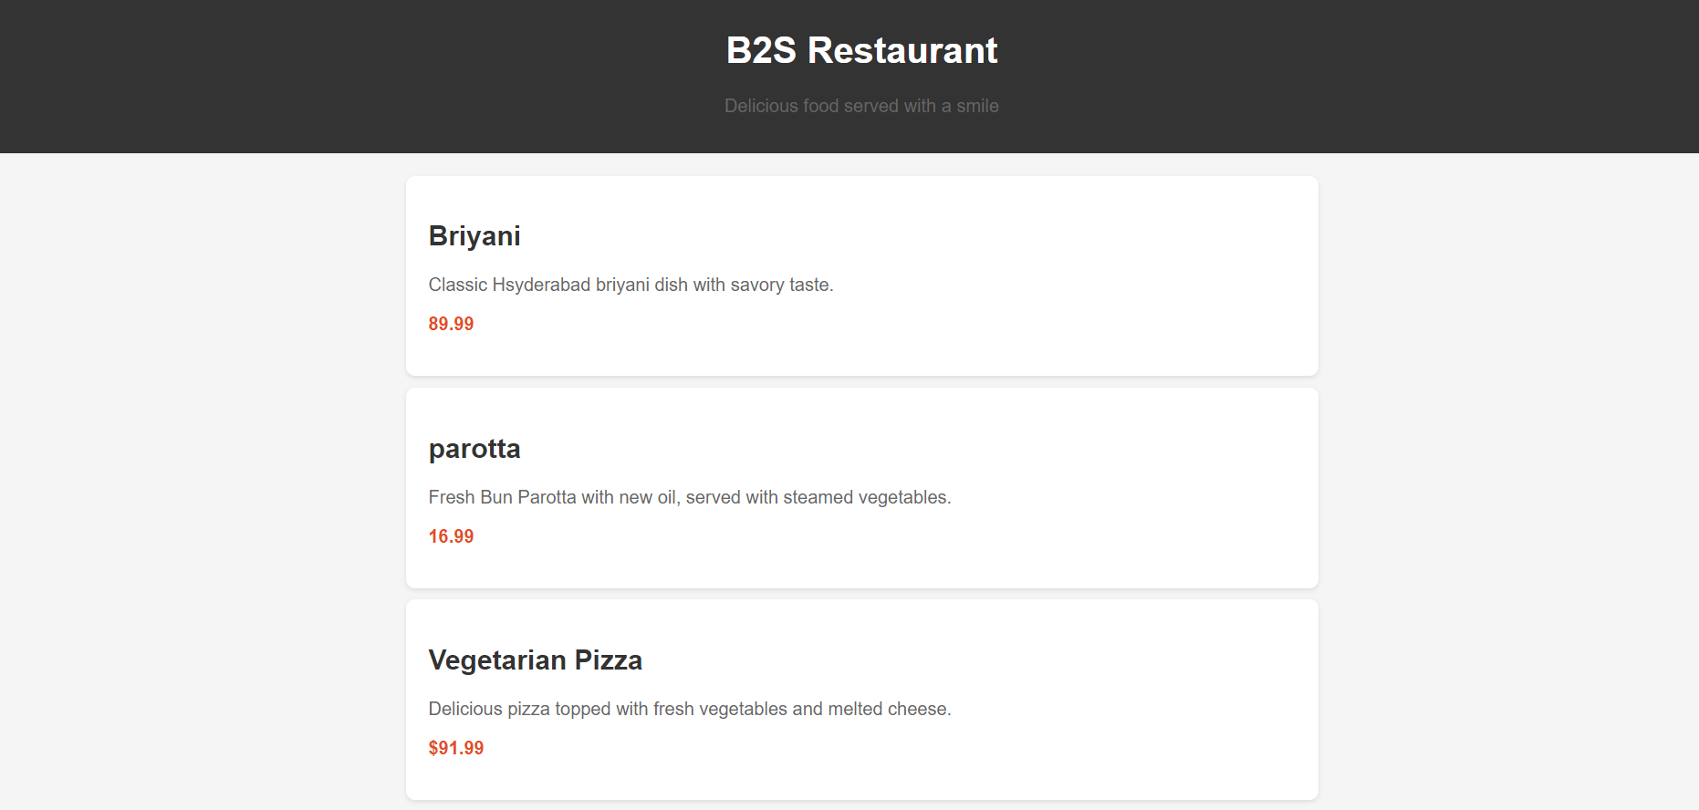

CONTACT US:

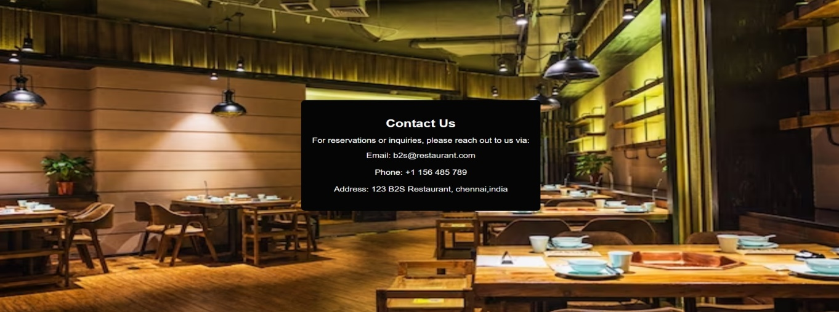

RESERVATION PAGE:

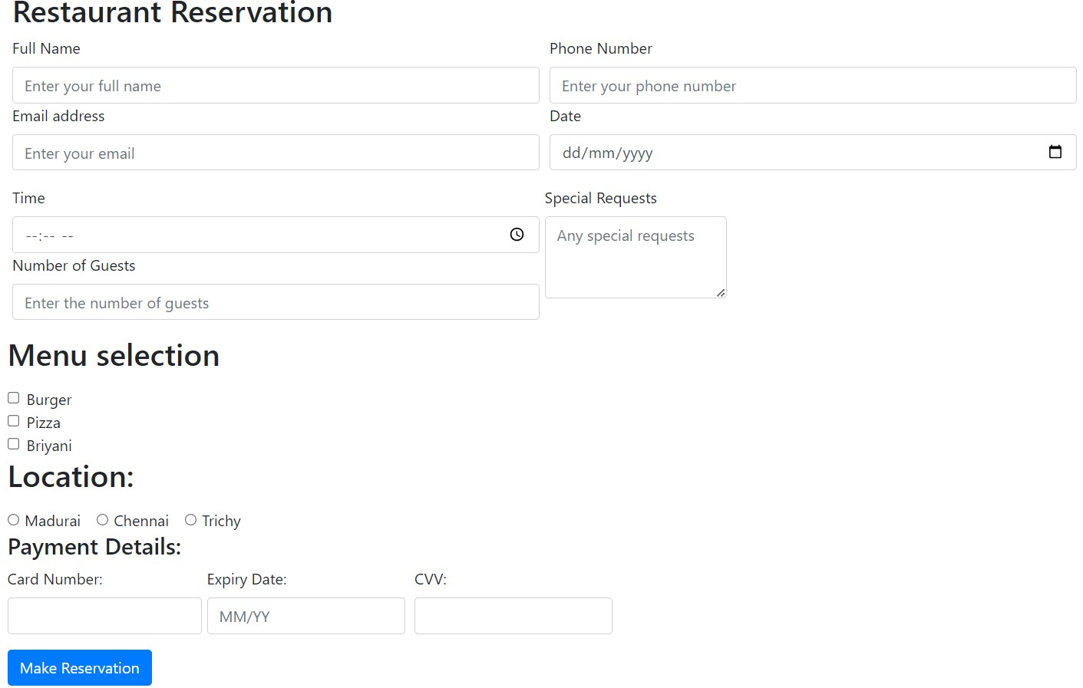

FOOTER:

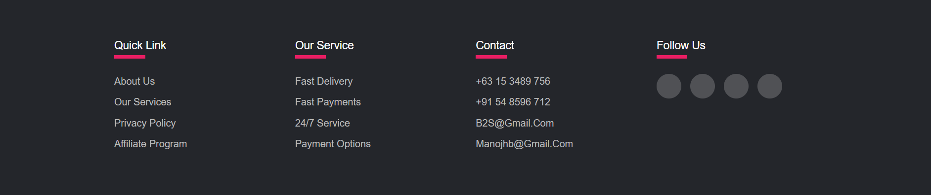

RESULT:

A Responsive Html and CSS website is created successfully.

By B.MANOJH (23CSR125)